|  |  |
| --- | --- |
| PROJECT ANALYSIS  Week 3 Assignment | ABSTRACT  This document was created for UMUC Course, CMSC 495, and analyzes aspects of the (TNC)  Group 3 Members  Name: Christiano, Andrew  Name: Fernandez, Yrume  Name: Orwick, Brian  Name: Sell, Julia  Class: CMSC 495 - Current Trends and Projects in Computer Science Professor: Dr. Hung Dao  Due: 10 September 2018 |

**Version Control**

|  |  |  |  |  |
| --- | --- | --- | --- | --- |
| Revision # | Date | Name | Descriptions | Contact Info |
| TNC_0001 | 9/4/2018 | Brian Orwick | Created | Orwick12@outlook.com |
| TNC_0002 | 9/7/18 | Julia Sell | Updated for Friday meeting | selljm14@gmail.com |

**Table of Contents**

1. **Outside Systems**
2. **Input Data**
3. **Output Data**
4. **Data Processing**
5. **Subsystem Requirements**
6. **Data Interface**
7. **Potential Risk and Mitigation**
8. **Future Enhancements**

**Outside Systems**

The user

**Input Data**

News articles from free, online news publications.

**Output Data**

A numerical rating of the trustworthiness of the news article based on its similarity to other articles on the same topic.

**Data Processing**

Scrape the web for to find free articles from reputable news organizations. Input the full text article and analyze it using the newspaper3k library. Compare the contents of the article to other articles with the same topic, and consider the likeness of similar articles. Compute a rating overlap between articles.

**Subsystem Requirements**

Web Scraper, Database, Article Analyzer, Article Comparator, Trust Calculator

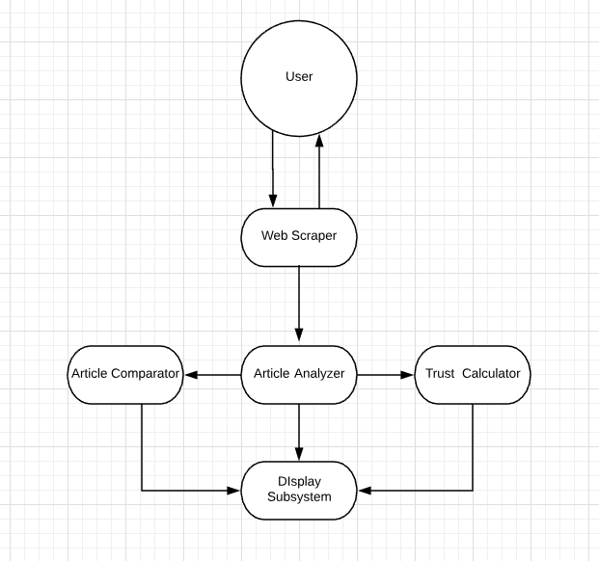

**Data Interface**

Display a feed of articles with their trustworthiness rating

Articles can be sorted by trustworthiness rating, originating news organization, or date of publication

The user may also rate the article after reading for trustworthiness

**Potential Risk and Mitigation**

**Future Enhancements**

Sentiment analysis to further consider the text of the articles

visualizations to illustrate vocabulary, determine the relationships between word choice and trustworthiness